A9-Afr-Tanzania-Olduvai Gorge-Olduwan Tool-Light Duty Scraper-3.2 Mya

Figs. 1-2.Olduvai Gorge-Olduwan Tool- Light Duty Scraper -3.2 Mya

**Case no.: 1**

**Accession Number:**

**Formal Label:** Tanzania-Olduvai Gorge-Olduwan Tool- Light Duty Scraper -3.2 Mya

**Display Description:**

This Light Duty Scraper was used in conjunction with scraping flesh from hides preparatory to eating the flesh or making clothing. (see Leakey 1971, Fig. 103). Olduwan tools represent the earliest stone tool industry in prehistory. This artifact is from the Olduvai Gorge, Tanzania and was made by Australopithecus Afarensis

**LC Classification:** [**GN776.T3**](http://luna.wellesley.edu/search~S1?/mq+GN776.T3+L42/mgn++776+t3+l42/-3,-1,,B/browse)

**Date or Time Horizon:** 3.2 Mya

**Geographical Area:** Olduvai Gorge, Tanzania.

**Map:**

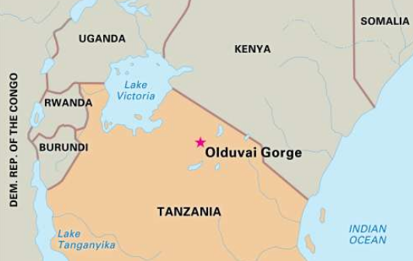

**Fig. 3. Location of olduvai gorge after https://cdn.britannica.com/700x450/05/19705-004-7B925915.jpg**

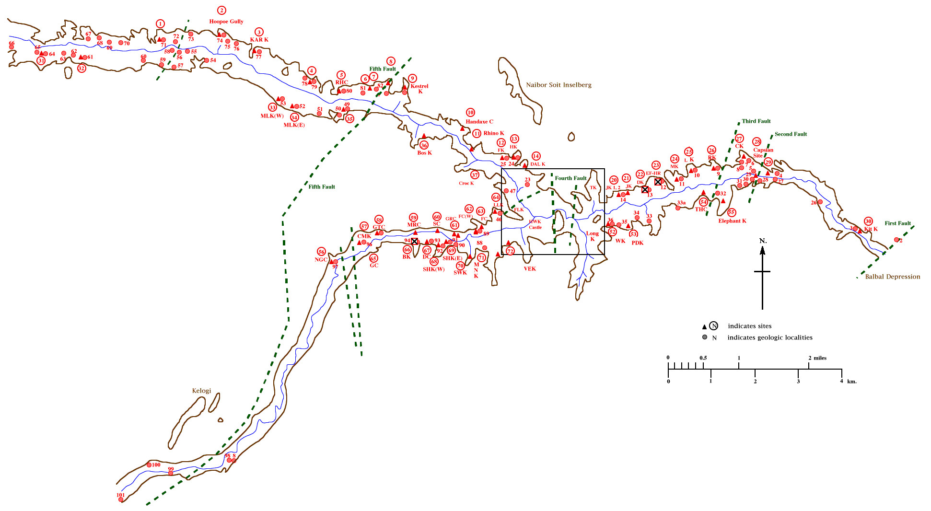

**Fig. 4. Olduvai Gorge after** [**https://archserve.id.ucsb.edu/courses/anth/fagan/anth3/courseware/OlduvaiArch/images/M**](https://archserve.id.ucsb.edu/courses/anth/fagan/anth3/courseware/OlduvaiArch/images/M) **asterMap.gif**

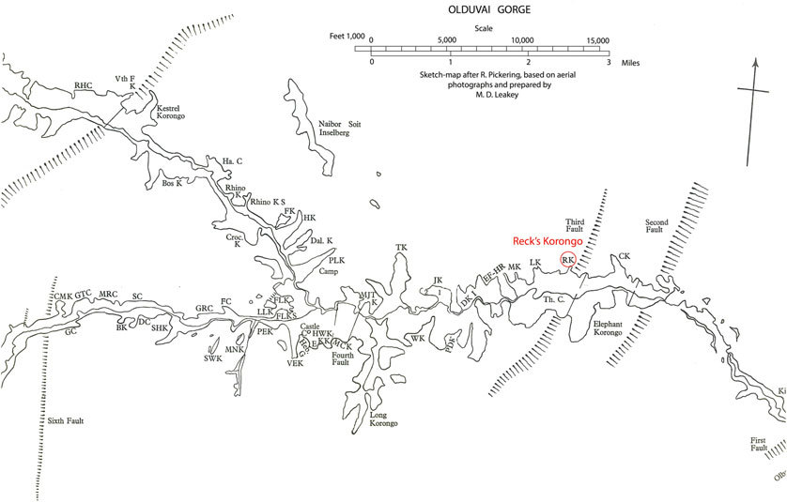

Fig. 5. Olduvai gorge  showing the location of the Olduvai Hominid 1 found (modified after L.S.B. Leakey, 1967). After https://www.researchgate.net/profile/Jean-Bernard_Huchet/publication/315593692/figure/fig2/AS:514490669244416@1499675542071/Map-of-Olduvai-Gorge-showing-the-location-of-the-Olduvai-Hominid-1-found-modified-after.jpg

**GPS coordinates:**

**Cultural Affiliation:** Olduwan tool industry

**Medium:** silicified sandstone

**Dimensions:**

**Weight:**

**Condition: original**

**Provenance:** Olduvai Gorge, Tanzania

**Discussion:**

**References:**

Leakey, Mary D. 1971 Olduvai Gorge. Cambridge: Cambridge University Press.